10.57: 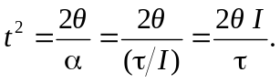
The angle in radiants is 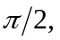 the moment of inertia is

and the torque is 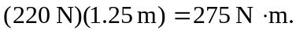 Using these in the above expression gives 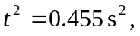 so 